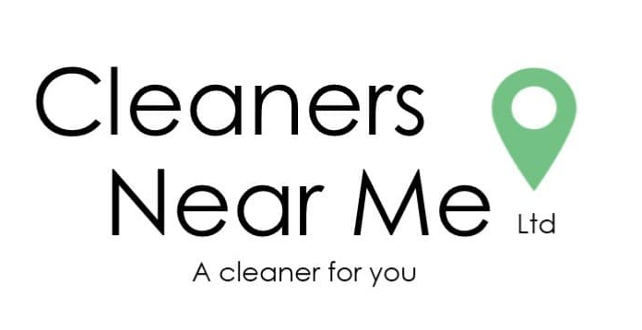

GDPR

Policy

Final Version, May 2020

Update Due, May 2022


CONTENTS

Table of Contents
GDPR – The General Data Protection Regulation 2
DATA PROTECTION 3
PERSONAL EMPLYEE DATA 3
CLIENTS AND SUPPLIERS 3
COOKIES AND WEBSITE 4
RIGHTS UNDER GDPR 4
FURTHER INFOMATION 4

INTRODUCTION

GDPR – The General Data Protection Regulation

The GDPR (General Data Protection Regulation) of 2018 replaces the current Data Protection Act of 1998. Both Employers and their employees have new responsibilities to consider and help ensure compliance. After Britain leaves the European Union, a new UK Data Protection Act will ensure that the GDPR principles remain in the UK law.

DATA PROTECTION

Cleaners Near Me Ltd may be required to collect, process and store data which relates to its stakeholders, including our employees, customers, suppliers, etc., in order for the company to carry out its duties, right and obligations. All information and data stored, is done so securely in accordance with the principles of Data Protection Act 2018. The company may require changing its data protection procedures from time to time to continue to comply with changing legislation.
The information will be used primarily for personnel, administrative and payroll purposes; however, there may be other requirements for data collection in association with the company’s business operations. The company will adopt appropriate organisational and technical measures to prevent the unauthorised use of unlawful processing or disclosure of data.

PERSONAL EMPLYEE DATA

We may require, in the case of our employees, to collect personal data, this may include:
- Name, Address and Date of Birth.
- Job Title.
- Contact Telephone Number and Email Address.
- Bank account details.
- Health Conditions and medicine and treatments taking.
- Any Alleged Offences and/or Criminal Convictions (whether spent or impending).

Some of this data is classed as “sensitive personal data”. This may include information relating to racial or ethnic origin, trade union membership, physical or mental health or existing medical conditions and any alleged offences and/or criminal convictions.
Anybody applying for a work position at Cleaners Near Me Ltd will be asked to provide/confirm their personal and/or sensitive personal data as required. By providing this information, they will allow consent to Cleaners Near Me Ltd collecting, processing and storing this information.

CLIENTS AND SUPPLIERS

We will require to process customer information which includes their address, contact information (including key contacts, telephone numbers, and emails), site specific information etc. We are committed to ensuring that your information is secure. We have put in place company procedures to ensure that your information is held securely and safeguarded at all times.
We may occasionally send out promotional literature or information on new services or products which we think you may find interesting. We may also send out information on changes in legislation which may affect the services we, or our sub-contractors provide to our customers. We may contact you by e-mail or if you utilise the Twitter page via our website, we will also provide information at periodic intervals.

COOKIES AND WEBSITE

Our Company uses Google and for a standard implementation of Google Analytics. Google collects a lot of data from every visit / visitor to your website, but it does not store any personally identifiable information. A visitor’s IP address (which is now recognised as personal data by GDPR) is used to determine their physical location but the IP address itself is not data that can be accessed through Google Analytics. All data in Google Analytics is aggregated and anonymised.

RIGHTS UNDER GDPR

Where the Act classifies you as a ‘Data Subject’, you have a number of rights under the Act. This includes the right to:
- Access the personal data the company holds about you.
- Have inaccurate data corrected or removed by the company.
- Prevent the processing of information which may damage your Company’s reputation and image.
- Prevent unsolicited marketing.

FURTHER INFOMATION

You can find more information on Data Protection from the Information Commissioner’s Office at www.ico.org.uk

